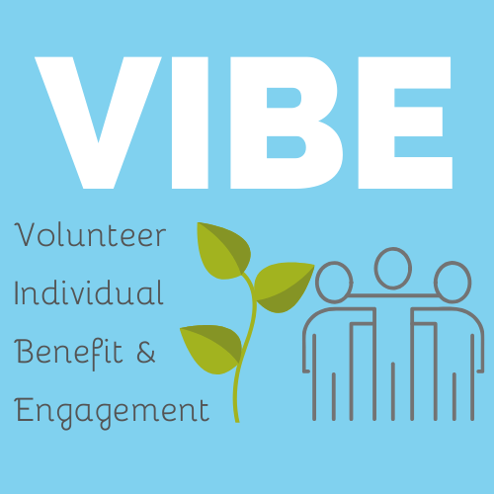
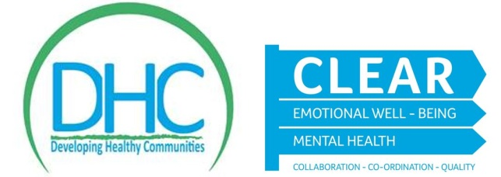
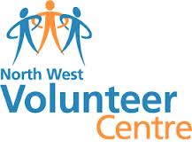

Volunteer Individual Benefit & Engagement
(VIBE) Tool Questionnaire

The North West Volunteer Centre (NWVC) has been funded by the Clear Project to deliver “Volunteering living your best life”. The project has 2 main objectives:

- Through the delivery of workshops in the DCSDC area, create awareness on local volunteering and the health & wellbeing benefits derived from volunteering

- Create and carry out the VIBE measurement tool on 50 volunteers to highlight the personal benefits and impacts of volunteering based on the 5 steps to wellbeing across the Derry City and Strabane District council area.

The North West Volunteer centre would like to thank you for taking the time to complete the VIBE tool questionnaire. The information gathered from this survey will be completely confidential and collated with other anonymous volunteer responses and presented in overall report

- How long have you been a volunteer? ________Years _____months

- What type of organisation do you volunteer with?
(Please select 1 category only)

Sport |  | Arts & Culture
Community group |  | Health
Faith |  | Youth
Older people |  | Disability
Education |  | Children
Early years |  | Other (please specify)
Ethnic Minorities
- Current home Post Code_________________ Live in ROI

- Age category

25 or under 26 to 34 35 to 44

- o 54 55 to 64 65+

- Why did you become a volunteer (please tick ALL that apply)

- I wanted to make a difference

- I wanted to meet people/make friends
- The cause was really important to me

- It provides me with structure and makes good use of my time

- It was connected with the needs of my family/friends

- I thought it would give me a chance to learn new skills /use existing skills
- To help me improve employability /career

- It gave me a chance to get a recognised qualification

- I was asked to help out

- Other Please specify__________________________________________
Additional comments

- Would you recommend volunteering? Yes No

- What do you think would encourage people to volunteer?
  - Local promotional campaigns and information about volunteering
  - Training opportunities
  - Access to out of pocket expenses
  - Taster sessions
  - Other______________________________________________________
Additional comments

- What have been the challenges for you as a volunteer?
  - I have not experienced challenges in my volunteering
  - Financial /lack of out of pocket expenses/ costs
  - Commitment
  - Overreliance/too much
  - No defined role
  - Lack of support
  - Poor volunteer management
  - Personality clashes with others
  - Other_____________________________________________________

Additional comments

- Please answer EACH of the following statements based on your most recent/current volunteering experience

From being a volunteer…… | Agree | Disagree | Not applicable
I feel valued and part of a team
I gain new contacts and networks
It opens doors to new opportunities
I’ve developed new friendships
I feel part of my local community

As a volunteer……. | Agree | Disagree | Not applicable
I can help improve things locally
It builds my confidence
I feel less isolated
Provides structure to my day
Allows me to give something back
It lets me feel good about myself by doing good
It allows me to demonstrate the things I am good at
It boosts my mental wellbeing

For me, through my volunteering….. | Agree | Disagree | Not applicable
I enjoy helping others
I enjoy feeling useful and needed
It broadens my experience of life
Lets me become more aware of local issues
Provides a welcome focus for me
It takes my mind off my own problems
It develops my skills and experience
Improves my career/education/job prospects
It helps to build recognised qualifications

My volunteering experience has | Agree | Disagree | Not applicable
Allowed me access to learning opportunities
Helped me to be more active – get out and about
Boosted my sense of well being & lifts my spirits

For me, volunteering….. | Agree | Disagree | Not applicable
Is a healthy lifestyle choice
Is a very worthwhile thing to do with my time
Can help reduce isolation
Helps improve my mood
Helps reduce anxiety and stress

- What have you been most proud of from your time volunteering?

- How do you feel volunteering has impacted on you?

If you wish to provide more information about your volunteering experience, we would love to capture your feedback. Please utilise the space at the back or email strabane@volunteeringnorthwest.co.uk
Thank you for taking the time to complete this questionnaire.
The completed overall report will be available to download from
www.volunteeringnorthwest.co.uk in March 2020.

